**Boseong Festival**

One of the country’s biggest spring festivals, the Boseong Green Tea Festival returns for a nine-day run this week.

Taking place at the Korean Tea Cultural Park and Boseong Tea Fields, the festival runs from April 29 through May 7th.

Probably Korea’s most famous tea-growing region, the orderly hedges of tea shrubs create a picturesque backdrop for the annual green tea festival, which offers visitors a number of tea-related cultural activities and even green tea-themed foods, like green tea ice cream and pork belly.

[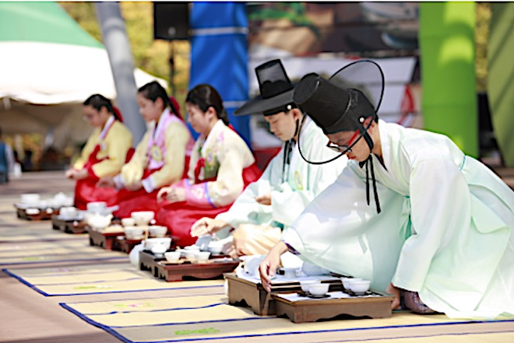](https://www.hapskorea.com/wp-content/uploads/2017/05/boseong-tea-festival.jpg)

Image: Boseong Tea Festival

Hands-on experiences such as making and picking tea as well as sampling snacks also add to the great festival experience.

The event is open to people of all ages.

Boseong Green Tea Festival is held every May in Boseong Tea Plantation listed on “31 Beautiful Sights on This Incredible Planet” by CNN.

*From Busan, you will want to take the Namhae Expressway to the Gwangyang IC. Next, get off at the Suncheonman IC and get on the Mokpo-Gwangyang Expressway to the Boseong IC and finally to the Jangsugyoja-ro.*

[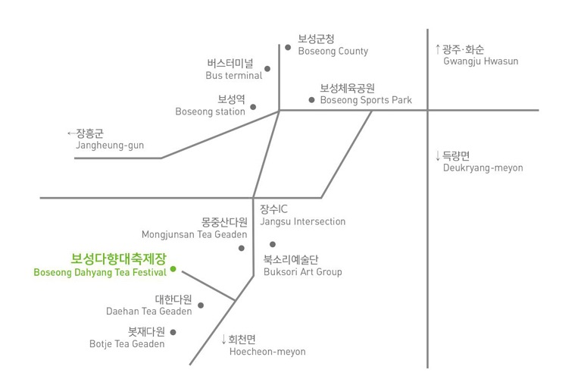](https://www.hapskorea.com/wp-content/uploads/2017/05/Boseong-Map-English.jpg)